**Guide to learning about your country and its vulnerability to climate change**

**This document gives a little background on climate risks (more to come in the lectures) and provides you with some guiding questions and resources for finding out about the conditions in your country.**

A climate **risk** is a realized or potential threat to lives, livelihood or some valued thing from climate change. Climate risks can be thought of as comprising 3 interacting elements:

A physical **hazard** – a change in climate conditions that potential poses some threat, e.g. an increased likelihood of river flooding.

The **exposure** of the system affected to the hazard – e.g. the population living in currently flood-prone regions or those likely to be exposed to this risk in future.

The **vulnerability** of the system affected – the susceptibility of the system affected to suffer harms as a result of the climate hazard, e.g. farmers who have no insurance and limited resources to cope with loss of crops exposed to a flood risk are more vulnerable than wealthier farmers with insurance and sufficient resources to weather bad years.

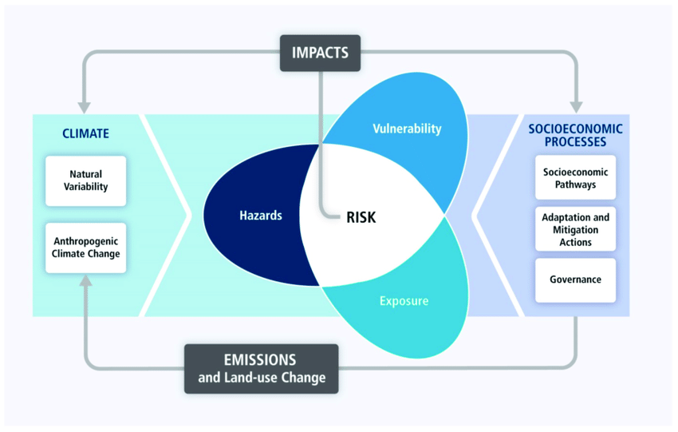

In this project I want you to do some research to find out about the state of your country, it’s exposure and vulnerability to climate risks. **Below I give you a lot of information, but I don’t expect you to learn everything about your region and its climate risks!** Instead, use the questions and resources below as a guide to help you gather some information on your country and its exposure and vulnerability to climate change.

**What are the key risks of climate change, are some particularly worrying in your region?**

* The Intergovernmental panel on climate change’s climate impact report has LOTS (too much for your purposes) of useful material on the risks of climate change but here are some highlights:
  + In table TS3 of the [technical summary](https://www.ipcc.ch/site/assets/uploads/2018/02/WGIIAR5-TS_FINAL.pdf) the 8 key global risks of climate change are listed broken with the relevant climate hazards, exposure and vulnerability explained.
  + The [summary for policymakers](https://www.ipcc.ch/site/assets/uploads/2018/03/ar5_wgII_spm_en-1.pdf) gives a simple, though extensive summary of climate impacts, there is a useful discussion of key regional risks starting on page 21.
  + There is a much more detailed discussion of regional risks in different chapters, listed [here](https://www.ipcc.ch/report/ar5/wg2/)
  + Your country may have written reports summarizing the risks of climate change for it, try searching for these (e.g. the [UK’s climate risk report](https://www.theccc.org.uk/tackling-climate-change/preparing-for-climate-change/uk-climate-change-risk-assessment-2017/))

**What is the geography and climate of your country and how does it compare to others?**

* You can compare the climate results in your jupyter notebook for your region to others to get some sense of this.
* Wikipedia and other sources can give you other basic facts (is it low-lying? dry? Cold? Is there a mega-delta?)
* You can find out about the water stress (low availability of fresh water per capita) in your country [here](https://wri.org/applications/aqueduct/country-rankings/)

**What are the basic social and economic facts about your country as well as pertinent recent historical events?** (What are the demographics? How wealthy is it per capita? Do many people live by subsistence agriculture? Is it at war or has it recently been at war? Is there a government safety net or are people left to fend for themselves? Etc.):

* [CIA world factbook](https://www.cia.gov/library/publications/the-world-factbook/attachments/summaries/YM-summary.pdf) and wikipedia
* **Hint:** much depends on GDP per capita and how well evenly its distributed (Gini coefficient)

**How does your country compare to others?**

* [Gapminder](https://www.gapminder.org/tools/) has a useful tool that let’s you compare your country against others along a range of different metrics (highlight your country using the column on the right, and change the X and Y axes).
* They have a great series of [videos](https://www.gapminder.org/videos/reducing-child-mortality-a-moral-and-environmental-imperative/) explaining the state of the world that will help you contextualize some of this. Some highlights: [value of economic growth](https://www.gapminder.org/videos/hans-rosling-and-the-magic-washing-machine/), [How the world is converging](https://www.gapminder.org/videos/hans-rosling-on-cnn-us-in-a-converging-world/), [the importance of reducing child mortality](https://www.gapminder.org/videos/reducing-child-mortality-a-moral-and-environmental-imperative/)
* [Our world in data](https://ourworldindata.org/future-population-growth) has articles on a wide range of topics that show data comparing countries.

**What does life look like in your country? How vulnerable do you think people living in your country are?**

* Check out [DollarStreet](https://www.gapminder.org/dollar-street/matrix?thing=Homes) from gampinder.org:
  + Search for your country or one with a similar GDP/capita and see what kind of homes / lives people in that country have.
  + Alternatively, take the purchasing power parity GDP per capita of your country, divide by 12 to get a central value and then check within 20% and 500% of that value to get a reasonable range of homes / lives (in the UK PPP GDP per capita that would be $39,720 / 12 = 3310 so between $600 and $18,000)
  + **Tip:** Consider using one of your figures to show what life looks like in your country